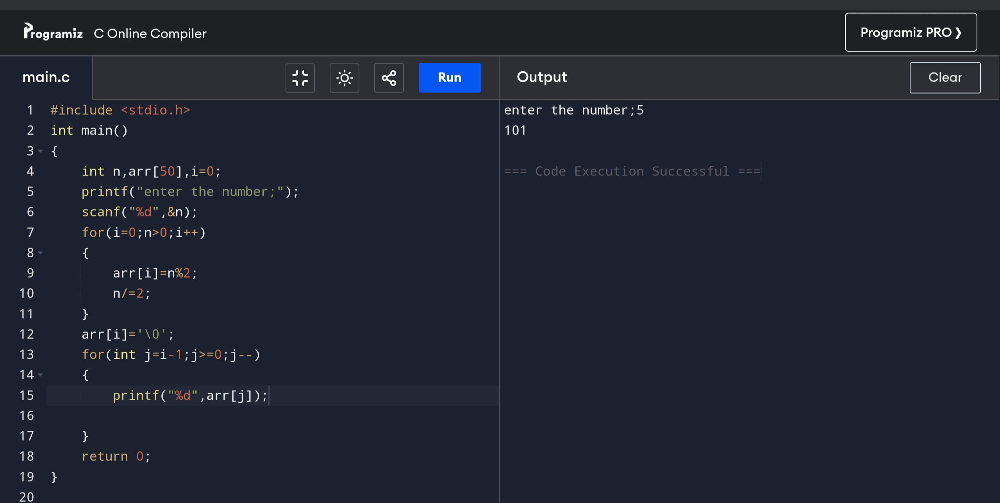

1).

#include<stdio.h>

int main()

{

int n,arr[50],i=0;

printf(“enter the number:”);

scanf(“%d”,&n);

for(i=0;n>0;i++)

{

arr[i]=n%2;

n/=2;

}

arr[i]=’\0’;

for(int j=i-1;j>=0;j–)

{

printf(“%d”,arr[j]);

}

return 0;

}

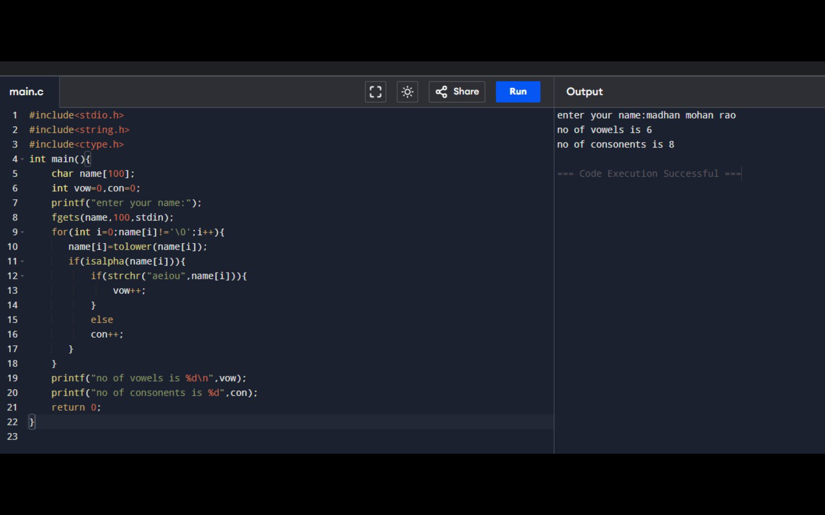

2).

#include<stdio.h>

#include<string.h>

#include<ctype.h>

int main(){

char name[100];

int vow=0,con=0;

printf("enter your name:");

fgets(name,100,stdin);

for(int i=0;name[i]!='\0';i++){

name[i]=tolower(name[i]);

if(isalpha(name[i])){

if(strchr("aeiou",name[i])){

vow++;

}

else

con++;

}

}

printf("no of vowels is %d\n",vow);

printf("no of consonents is %d",con);

return 0;

}

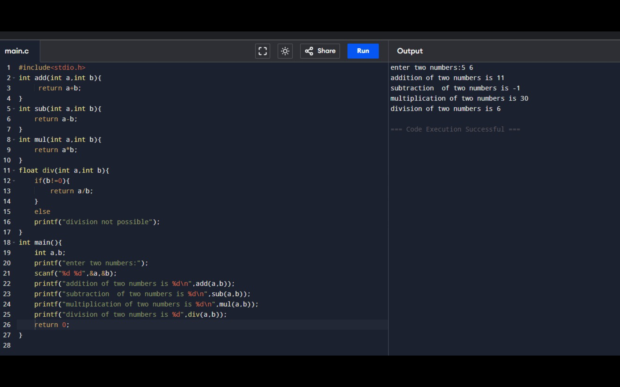

3).

#include<stdio.h>

int add(int a,int b){

return a+b;

}

int sub(int a,int b){

return a-b;

}

int mul(int a,int b){

return a\*b;

}

float div(int a,int b){

if(b!=0){

return a/b;

}

else

printf("division not possible");

}

int main(){

int a,b;

printf("enter two numbers:");

scanf("%d %d",&a,&b);

printf("addition of two numbers is %d\n",add(a,b));

printf("subtraction of two numbers is %d\n",sub(a,b));

printf("multiplication of two numbers is %d\n",mul(a,b));

printf("division of two numbers is %d",div(a,b));

return 0;

}

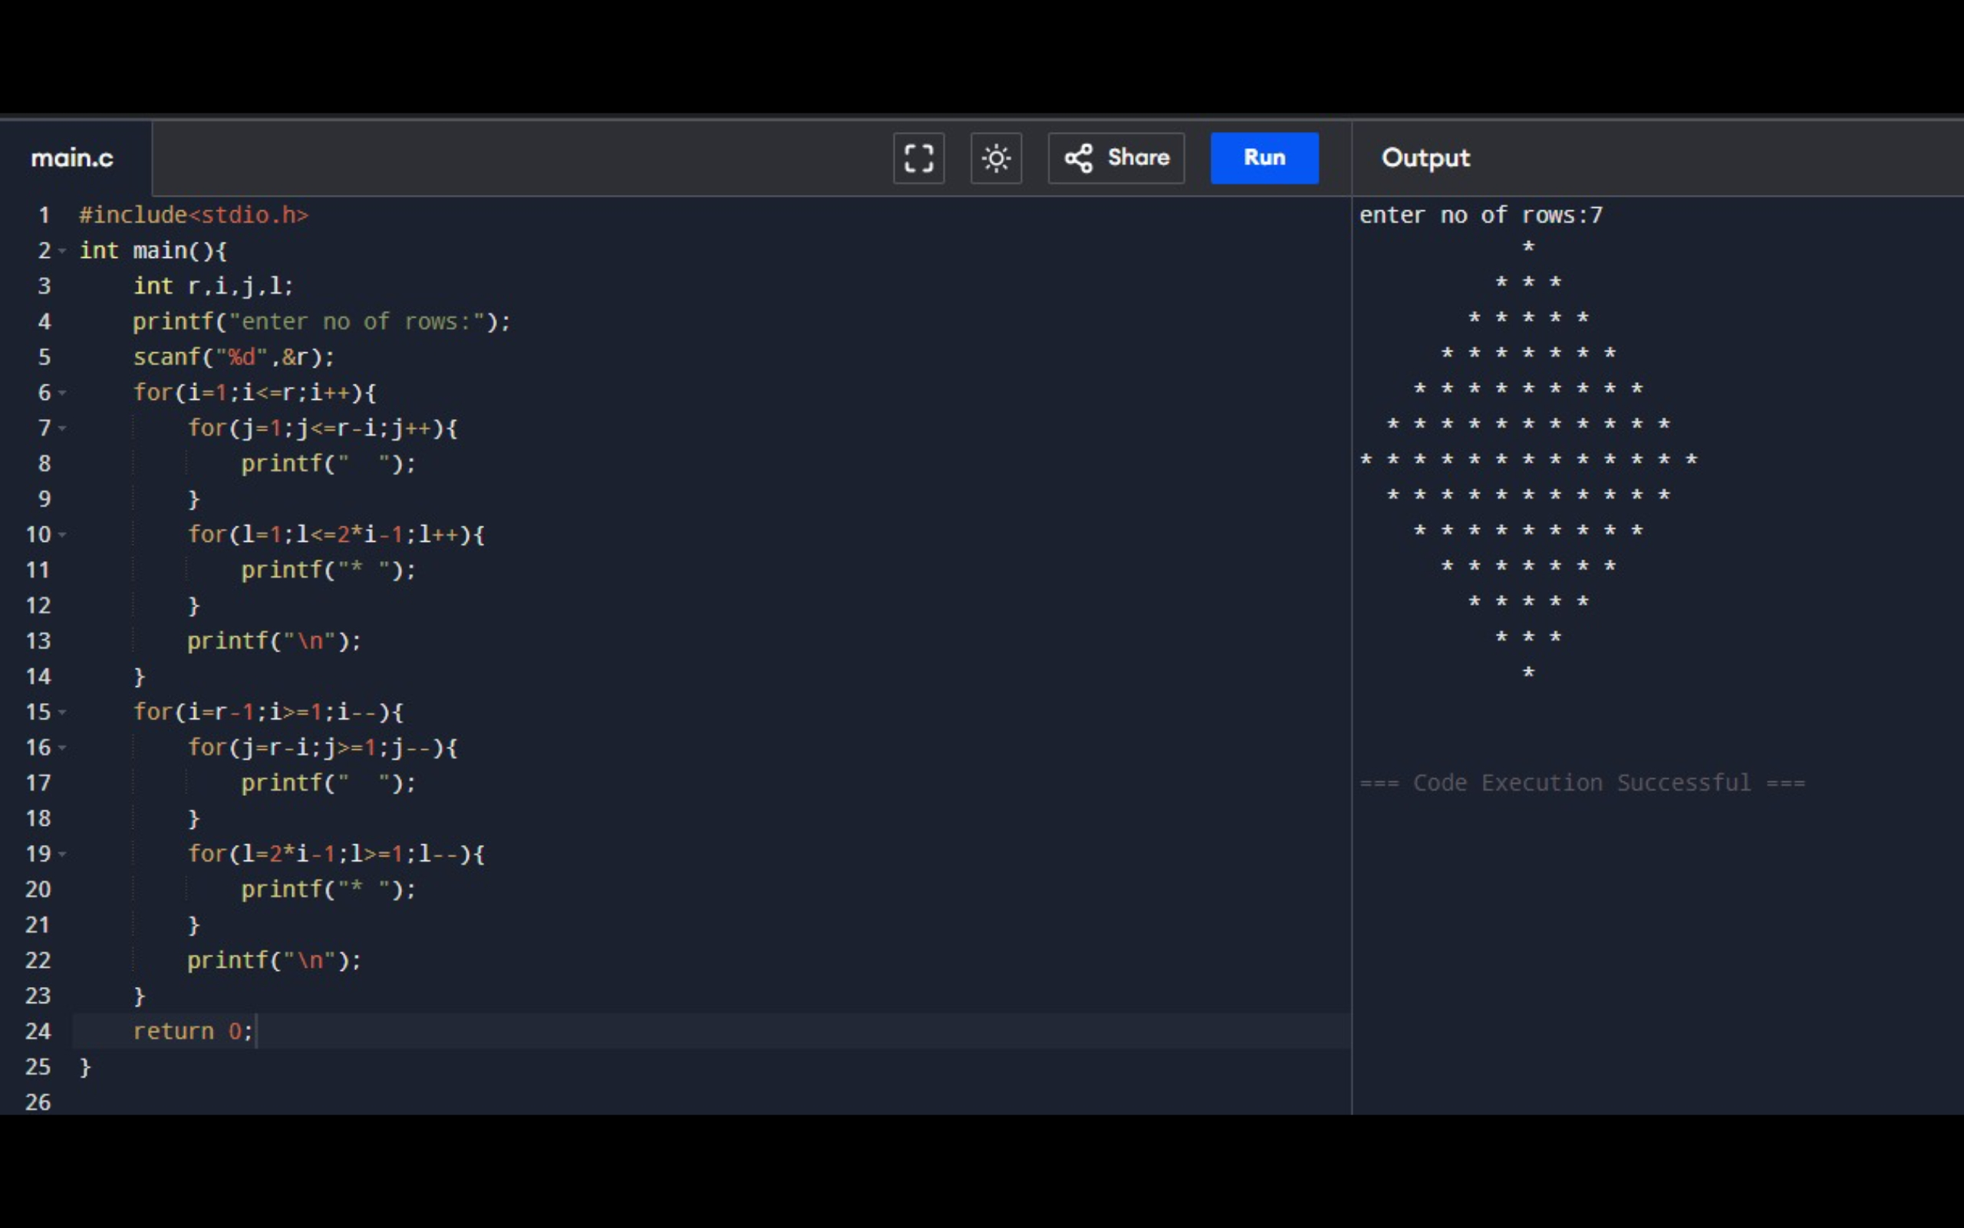

4).

#include<stdio.h>

int main(){

int r,i,j,l;

printf("enter no of rows:");

scanf("%d",&r);

for(i=1;i<=r;i++){

for(j=1;j<=r-i;j++){

printf(" ");

}

for(l=1;l<=2\*i-1;l++){

printf("\* ");

}

printf("\n");

}

for(i=r-1;i>=1;i--){

for(j=r-i;j>=1;j--){

printf(" ");

}

for(l=2\*i-1;l>=1;l--){

printf("\* ");

}

printf("\n");

}

return 0;

}

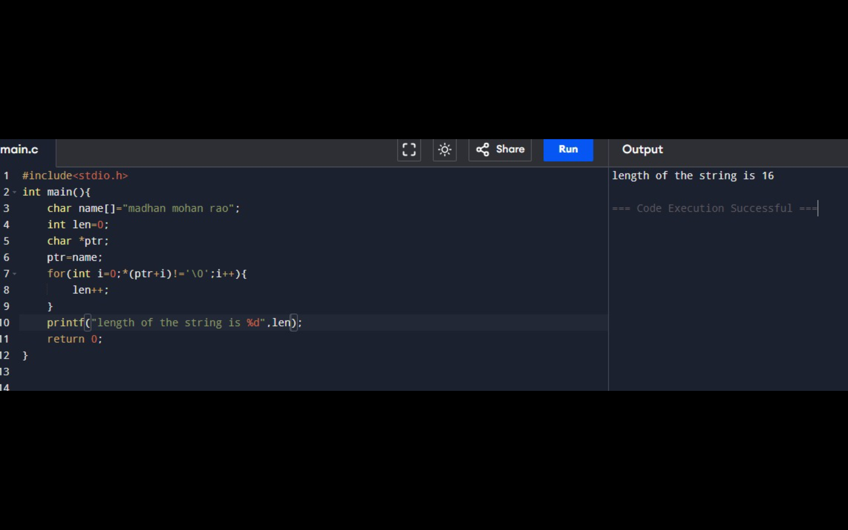

5).

#include<stdio.h>

int main(){

char name[]="madhan mohan rao";

int len=0;

char \*ptr;

ptr=name;

for(int i=0;\*(ptr+i)!='\0';i++){

len++;

}

printf("length of the string is %d",len);

return 0;

}

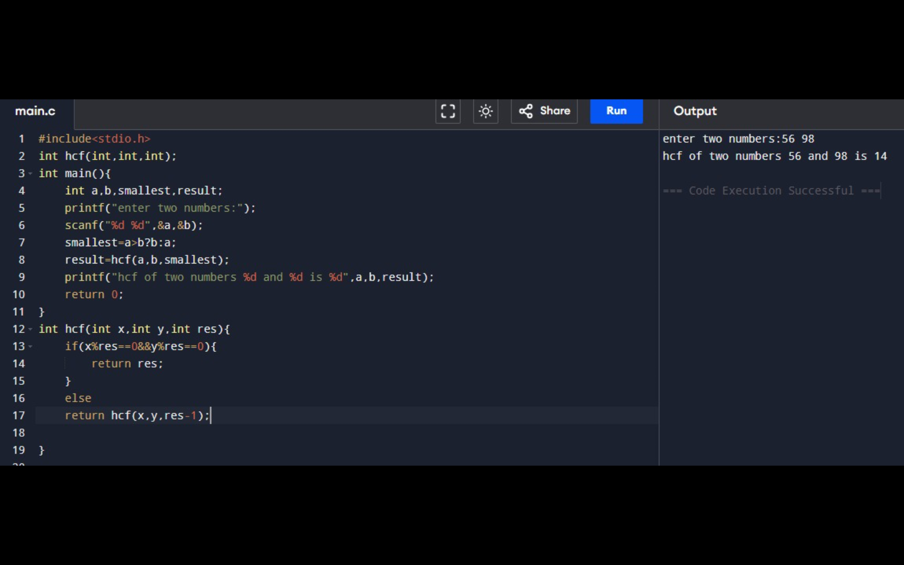

6).

#include<stdio.h>

int hcf(int,int,int);

int main(){

int a,b,smallest,result;

printf("enter two numbers:");

scanf("%d %d",&a,&b);

smallest=a>b?b:a;

result=hcf(a,b,smallest);

printf("hcf of two numbers %d and %d is %d",a,b,result);

return 0;

}

int hcf(int x,int y,int res){

if(x%res==0&&y%res==0){

return res;

}

else

return hcf(x,y,res-1);

}